coordinated by
Organized by

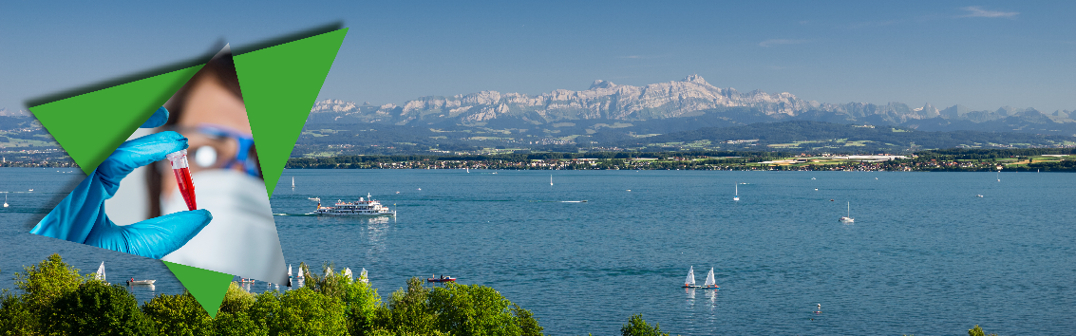
International
Diagnostics-4-Future Conference 2019
November 27 / 28, 2019
Konstanz (Lake Constance)

Exclusive Partnering and Exhibit Opportunities

With more than 150 attendees from different European countries the ‘Diagnostics-4-Future Conference‘ is THE international meeting-place for users and providers in diagnostics and adjacent fields. Based on questions in medical care, clinics and laboratories, innovative solutions for new diagnostics are discussed including research and development.

CONFERENCE PROFILE (WHO WILL YOU MEET? ...)
- International audience: 160 attendees from 8 countries (in 2018) - D, CH, A, LI,
ES, IRL, FR, NO
- 2 conference days
- 4 plenary sessions
- more than 20 speakers
- poster award
- plenty of networking space for 1-to-1 meetings to explore collaborations (welcome dinner, conference lunch, coffee breaks…)
- magnificent venues, directly on the shores of Lake Constance

This year's conference takes place on Nov. 27 and 28 in Konstanz at the historical Konzil located directly on the shores of Lake Constance.

IMPRESSIONS FROM LAST YEAR
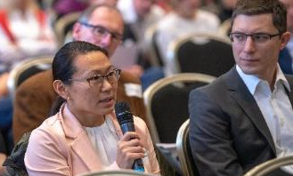
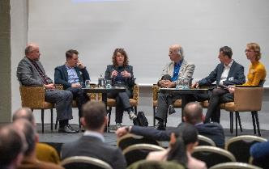
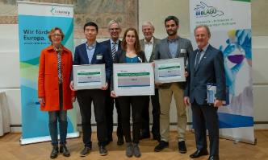
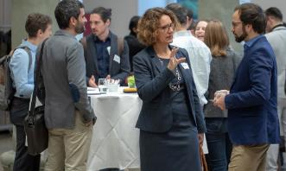
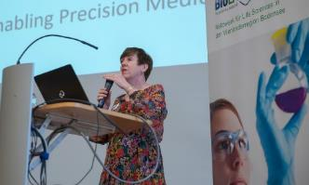
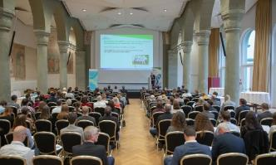

TARGET AUDIENCE
The conference brings together companies, laboratories, clinics, research institutions and health insurances / economists – in diagnostics and adjacent fields like medical technology, pharma and life
sciences.

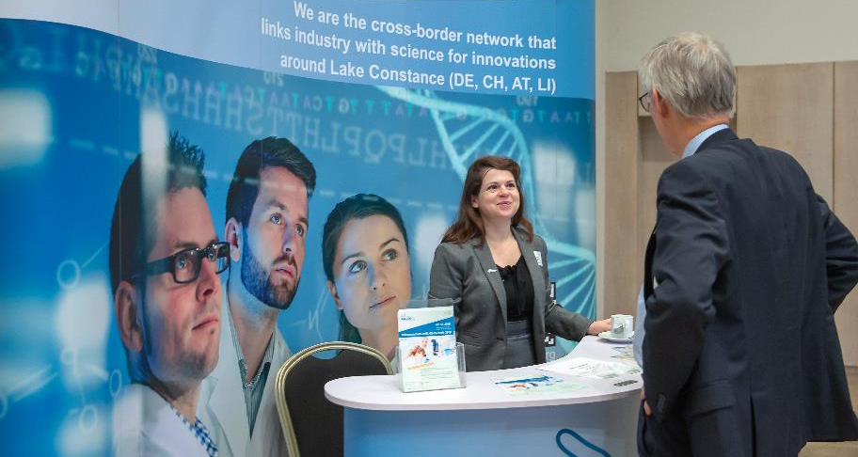
YOUR PARTNERING AND EXHIBIT OPTIONS

PLATINUM - Sponsorship
Special highlighting in the run-up and at conference!

- Exhibition booth (6 qm)
- 2 x conference tickets included
- Special highlighting and visibility at the conference
- Logo in event flyer (digital & print; 6.000+ recipients)
- Logo on event website (www.diagnostics4future.org)
- Logo on conference documents (handed out to every participant)
- Logo in presentations (welcome / final speeches, lunch and coffee breaks)
- Organized VIP roundtable at conference dinner (first day)
- Insertion of advertising material in conference folder
- Logo/naming in press release (international media)
- Further individual services are possible

Regular: 3.000 €*
BioLAGO member: 2.750 €*

GOLD – Sponsorship
High visibility in the run-up and at conference!

- Exhibition booth (4 qm)
- 1 x conference ticket included
- Logo in event flyer (digital & print; 6.000+ recipients)
- Logo on event website (www.diagnostics4future.org)
- Logo in presentations (welcome / final speeches, lunch and coffee breaks

Regular: 1.600 €*
BioLAGO member: 1.375 €*
_________________________________________________________________________________

SILVER – Sponsorship
Your presence during two conference days!

- Exhibition booth (2,5 qm)
- 1 x conference ticket included

Regular: 1.250 €*
BioLAGO member: 1.050 €*

_________________________________________________________________________________

Logo - Partnering
Your multifaceted presence in the run-up and at the conference!

- Logo in event flyer (digital & print; 6.000+ recipients)
- Logo on event website (www.diagnostics4future.org)
- Logo in presentations (welcome / final speeches, lunch and coffee breaks)

Regular: 450 €*
BioLAGO member: 375 €*

*All prices are in Euros and subject to 19% VAT.

Of course, we can set up individual packages for you.
The offer is exclusive and limited. Secure your space for the conference now!

Signing on earlier will allow you to maximize exposure to hard-to-reach decision makers.

OVERVIEW OF YOUR OPTIONS

 | Sponsor  PLATINUM  3.000 €*  BioLAGO  member  2750 €* | Sponsor  GOLD  1.600€*  BioLAGO member  1.375 €* | Sponsor  SILVER  1.250 €*  BioLAGO member  1.050 €* | Logo  partner  450 €*  BioLAGO member  375 €*
Exhibition booth | ✓  (6m²) | ✓  (4m²) | ✓  (2,5m²)
Included conference ticket | 2 tickets | 1 ticket | 1 ticket
Logo on event website and in event flyer | ✓ | ✓ |  | ✓
Logo on conference documents | ✓
Logo in presentations  (welcome speech, breaks) | ✓ | ✓ |  | ✓
Special highlighting and visibility at the conference | ✓
Organized VIP roundtable at conference dinner (first day) | ✓
Insertion of advertising material in conference folder | ✓
Logo/naming in press release (international media) | ✓

Special Sponsorship

Poster Award “Young talents meet Industry”: | 1.500 €* already booked
Live music at the conference dinner + package ‘logo partner’ (see above) | 1.250 €* BioLAGO member: 1.150 €*

*All prices are in Euros and subject to 19% VAT.

International
Diagnostics-4-Future Conference
Nov. 27 - 28, 2019 - Konstanz
Organized by
coordinated by
Exclusive Partnering and Exhibit Order Form

- Your Details

Name / contact person: Click or tap here to enter text.
Job Title: Click or tap here to enter text.
Organization: Click or tap here to enter text.
VAT no.: Click or tap here to enter text.
Address: Click or tap here to enter text.
Postal code / city / country: Click or tap here to enter text.
Tel.: Click or tap here to enter text.
Email: Click or tap here to enter text.

- Your Option

 | Sponsor  PLATINUM | Sponsor  GOLD | Sponsor  SILVER | Logo  partner
Regular | ☐ 3.000 €* | ☐ 1.600 €* | ☐ 1.250 €* | ☐ 450 €*
BioLAGO member | ☐ 2.750 €* | ☐ 1.375 €* | ☐ 1.050 €* | ☐ 375 €*

Poster Award “Young talents meet Industry”: | ☐ 1.500 €* already booked
Live music at the conference dinner + package “logo partner” (see above) | ☐ 1.250 €* BioLAGO member: 1.150 €*

*All prices are in Euros and subject to 19% VAT.

Your remarks: Click or tap here to enter text.

- Information from exhibitors

Do you need a connection for power supply (AC 230V)?

Yes ☐ No ☐

Do you need a table and chairs:

- Conference table (rectangular) ☐

- Chairs: Choose an element.

Your remarks: Click or tap here to enter text.

Logo

Please send us your Logo (eps AND jpg).

- Terms and conditions of booking

- The deadline for registration is Nov. 20th, 2019 at 11.59 pm (CET).
- Acceptance of applications for exhibits or sponsorship is at the discretion of the organizers.
- You will be provided with confirmation of your booking.

- Privacy Policy

With your signature you agree that BioLAGO e.V. may use the above data for event management purposes in accordance with the terms of the Privacy Policy (biolago.org/datenschutz/). This includes for example a list of exhibitors.

Date & Signature: ______________________________________________________

Please send the completed form to Michael.Statnik@biolago.org
You will receive a confirmation and payment details.

Contact us for any questions: BioLAGO e.V. – the health network,
Michael Statnik, Project Manager Diagnostics, Byk-Gulden-Str. 2, 78467 Konstanz, Germany
T.: +49 7531 92 15 25 -2, michael.statnik@biolago.org , www.biolago.org / www.diagnet.org

Images:
© Microgen – stock.adobe.com – woman
© Manuel Schönfeld – stock.adobe.com – bodenseebild

