coordinated by

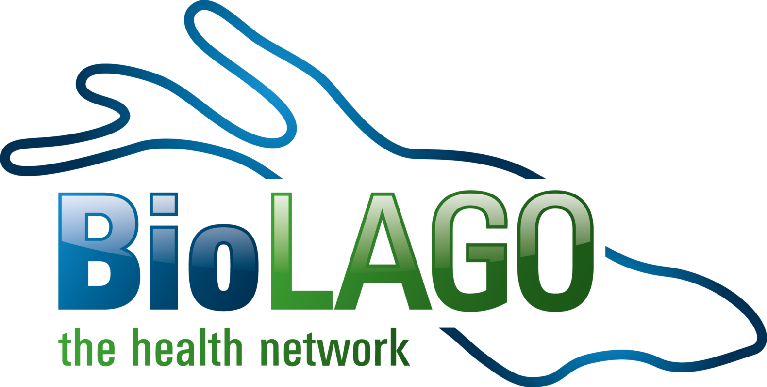

Diagnostics-4-Future Conference 2019
Nov. 27-28, 2019 Konzil, Konstanz (Germany)
- Call for posters -
Title of the abstract:

Author/s:
Name of the presenter:

Affiliation:

Description (maximum 1.500 characters with space)
Illustrative figures are optional (maximum 1)

Deadline for Submission: October 16th, 2019
Send the abstract to michael.statnik@biolago.org. Authors of accepted abstracts will be informed and can then bring along their heir poster (A0 format) to the symposium.

The Poster Award is powered by:

