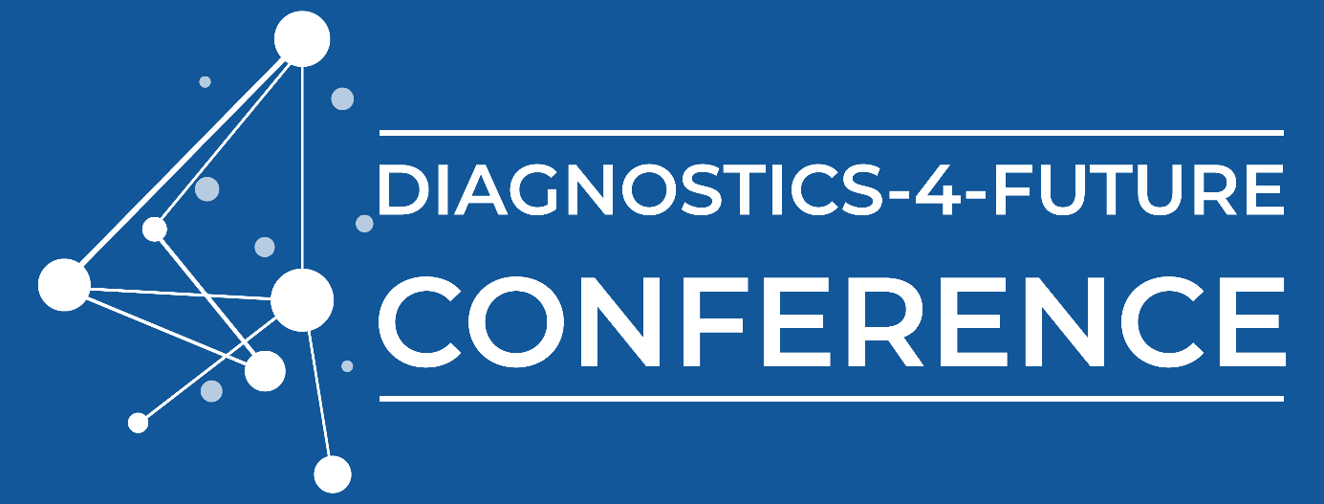

PITCH COMPETITION
Present your ideas on stage!
Date October 17th 2024 – Pitch ceremony
Location Bodenseeforum, Konstanz (Germany)
Chair Prof. Dr. David Drissner, Albstadt-Sigmaringen University / Board member
BioLAGO e.V.

General guidelines
- All registered participants are admitted to the pitch competition (except speakers)
- Ideas shall be forwarded using the idea card (template below)
- Your contribution shall relate to one of the main topics of the conference:
  - Affordable Diagnostics: setting the course for the future
  - AI-based Diagnostics for complex diseases
  - Future POC & Home testing: fast and precise… but also profitable
  - Detecting resistance on various levels
Application procedure
- Idea card to be submitted via e-mail to info@biolago.org until Oct. 14 23:59h or posted during conference. Submitted proposals will be placed on a white board on-site.
Voting process
- Oct. 16-17.: All participants vote according to their preferences using sticker points.
- Oct. 17 at 12.15h: On stage announcement of the voted Top 5 during Session 4, Oct. 17th at 12.15h.
Pitch presentations
- Oct. 17 at 14.00h: The voted Top 5 will present their ideas in conference session 5. Scheduled are 5 min. pitch + 3 min. for individual discussion.
- Smile! Photo date for the Top 5 pitchers right after the session
Your idea card
(to be filled out in English)
Name and organization:

Briefly describe your idea - formulate a need and outline a solution:

Please mark the category, which fits best:
☐ ageing ☐ cancer ☐ cardiovascular ☐ infectious diseases ☐ other
I’m looking for: ☐ Feedback ☐ Partners ☐ Funding/Investor
We’re looking forward to your ideas!
Your organizing BioLAGO team

